**Light – dark classification (config 1)**

Thank you for taking part in this experiment. We are interested in how humans classify “noisy” or uncertain sensory information. You will be paid up to $13 for your participation: you will get a base payment of $5, and will earn an extra amount between $5 and $8 depending on performance in a later part of the experiment. You will leave the experiment with a minimum of $10.

The experiment is divided into 2 phases. We will first give you the instructions for the first phase; the instructions for the second phase will be provided once you have completed the first phase.

***Phase 1:***This phase contains 350 trials. The figure below shows you the timeline of each trial. In each trial,you will see a square in the centre of the screen, filled with different numbers of white and black dots (e.g., 30% white, 70% black). When the majority of the dots are white, the patch will be lighter than the background; when the majority of the dots are black, the patch will be darker than the background. The patch will appear quite briefly, for around a quarter of a second. After that, two shapes will appear on the screen: a triangle and a rectangle. Using the mouse, click on the **triangle if you think the patch was a dark patch** (had more black dots than white dots), and on the **rectangle if you think the patch is light** (had more white dots than black dots). After each response, you will see a message telling you whether you classified the patch correctly or not (either the word ‘correct’ in green or ‘incorrect’ in red). Use this feedback to improve your discrimination ability in later trials.

As the proportion of black and white dots varies from trial-to-trial, there will be many trials in which you will be uncertain about whether the patch is more dark or light. Just do your best, and use the feedback to help you learn about what makes dark patches dark and light patches light.

You can have up to two breaks in this phase if you wish. A message will be displayed automatically on the screen to provide you with a break.

***Fixation***

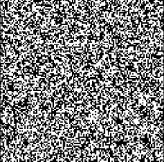

***Patch of dots***

**time**

***Choice***

***Feedback***

**Correct**

***Phase 2:***You have now reached Phase 2 of the experiment.

The second phase contains 200 trials. On each trial you will briefly see a patch. Your task isn’t to just work out whether the patch is dark or light, but to learn to predict which actions will provide a reward depending on the appearance of the patch. After each patch, you will see a circle and a square. You will need to click on the circle or the square to provide a response, and will then be given feedback about whether or not your response was correct and you won a reward on that trial. On trials in which you choose the correct response you will receive one money bag, worth 10 points; on trials in which you choose the incorrect action you will see a white money bag, worth 0 points.

Your task is to maximize your reward. In order to do this, you will need to learn which response to give based on the brightness of the patches that you see, and the rewards that you receive. As shown below, there are two possible correct mappings between the brightness of the patch and the correct shape to click on. It is important to note that the rewards are deterministic: if you give the correct response, you will always receive a reward. If you do not get a reward (i.e., you see the “0 points” feedback), it is either because you chose the wrong action, or you misidentified the true state of the stimulus (e.g., you saw a light patch as being dark). Although you cannot improve your ability to tell light and dark patches apart in this phase, you can improve your chances of getting a reward by learning the correct response to give depending on whether you think the patch is light or dark.

The number of points you will manage to collect in the second phase will be converted into dollars according to the following exchange rate: 200 points = $1. We have set up the experiment so that you can earn a minimum of $5 in this second phase (in addition to your base payment of $5), and can earn more than that depending on how quickly and well you learn which responses will be rewarded based on the patches you see.

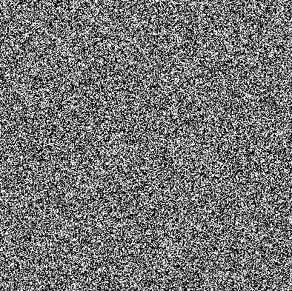

**Mapping 2 Mapping 1**

**Mapping 1 Mapping 1**